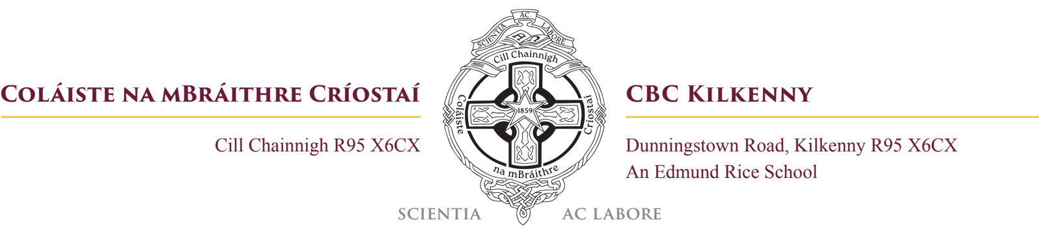
Subject Preference Form
1st Year 2026 - 2027
STUDENT’S NAME: _________________________________ Primary School: _______________
In addition to their core subjects, students will do “Option subjects” for their Junior Cycle.
Core subjects include: Irish, English, Mathematics, Science, History, Geography, Religion, and an EU Language.
Wellbeing forms a key part of the curriculum but is not examined by sitting a State Examination.
__________________________________________________________________________________
Section 1:
Students must select a European Language as a core subject. Please indicate your language preference by putting a number from 1, 2, 3 in the box next to each language. 1 indicates your first preference, 2 your next preference and 3 your last preference.

French German Spanish

__________________________________________________________________________________
Section 2:
- Students must choose two subjects from the list below:
- Every effort will be made to provide students with their preference however this will depend on school resources and option bands.
- The boxes should be marked 1, 2, 3, 4, 5 and 6 where “1” means the most desired subjects and so on.
All numbers from 1 - 7 must be used.

WOODWORK BUSINESS HOME EC ART

MUSIC TECHNOLOGY TECHNICAL GRAPHICS
__________________________________________________________________________________
Signed: _____________________________________ Parent Date: ___________
Signed: _____________________________________ Parent Date: ___________

Please return in paper form to CBC Kilkenny office by Friday May 1st 2026 at 16:30

